Photoelectron Spectroscopy Work Sheet

1. What is photoelectron spectroscopy?

2. How is it related to the photoelectric effect?

3. What does PES measure?

4. What is the electronic configuration of the atom with the following PES graph?

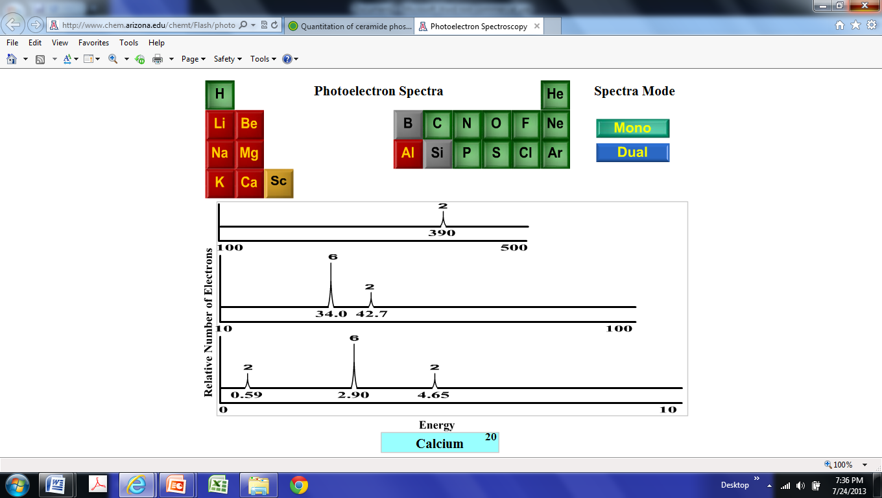

5. What is this atom? Circle the electron with the lowest ionization energy.

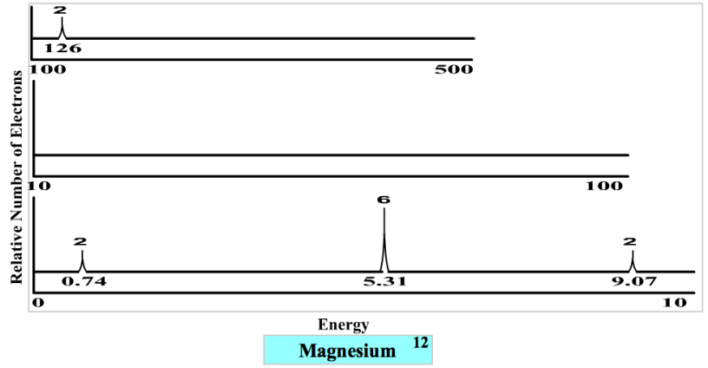

6. Draw a PES Spectra ( you may make up your own energy levels as long as they are relative) for Phosphorus. Label the shell, subshell and the number of electrons in each peak.

Energy

8. Identify each element by its PES spectra graph.

9. Write the electron configuration for each.

10. Circle the valence electrons on each graph.

11. What do each element have in common?

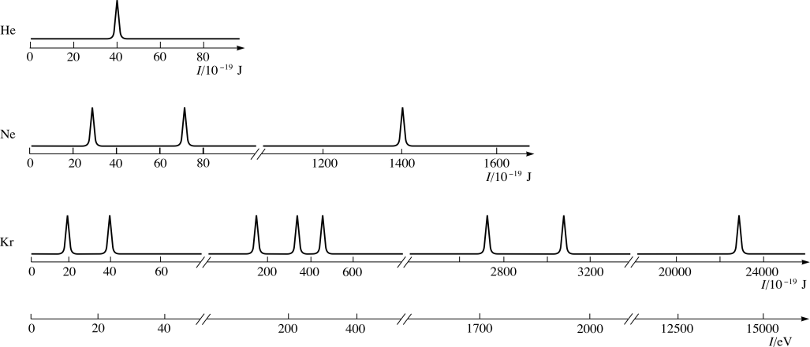



a) how many electrons do you see in the picture? *3* How many protons?

b) which of these electrons is the easiest (requires the least amount of energy)

to remove (ionize)?

c) Explain your response in b.

d) compare the energy from 3b with the energy in 2a and then in 2c.